**SUPPLEMENTARY MATERIAL FOR:** “Nitrogen demand, supply, and acquisition strategy control plant responses to elevated CO2”

**Results (cont.)**

*Leaf nitrogen content*

Elevated CO2 reduced *N*mass by 51% and increased *M*area by 44% (*p*<0.001 in both cases; Table S3; Fig. S1). Increasing nitrogen fertilization increased *N*mass and *M*area more strongly under ambient CO2 than elevated CO2 (CO2-by-nitrogen fertilization interaction: *p*<0.05 in both cases), resulting in a stronger reduction in *N*mass and a stronger increase in *M*area under elevated CO2 with increasing nitrogen fertilization than ambient CO2 (Fig. S2). Increasing nitrogen fertilization increased *N*mass and *M*area more strongly in uninoculated plants compared to inoculated plants (inoculation-by-nitrogen fertilization interaction: *p*<0.05 in all cases; Table S3; Fig. S1).

*Organ biomasses*

Elevated CO2 increased total leaf, stem, root, and root nodule biomass by 117%, 97%, 96%, and 70%, respectively (*p*<0.001 in all cases; Table S5). Increasing nitrogen fertilization increased total leaf, stem, and root biomasses (*p*<0.001 in both cases; Table S5) more strongly under elevated CO2 than ambient CO2 (CO2-by-nitrogen fertilization interaction: *p*<0.001 in both cases; Table S5), but decreased root nodule biomass (*p*<0.001; Table S5) similarly between CO2 treatments (CO2-by-nitrogen fertilization interaction: *p*>0.05; Table S5). Inoculation increased root biomass (*p*<0.05; Table S5), but this pattern was only observed under ambient CO2 (CO2-by-inoculation interaction: *p*<0.05; Table S5). Increasing nitrogen fertilization increased total leaf, stem, and root biomasses (*p*<0.001 in both cases; Table S5) more strongly in uninoculated plants than inoculated plants (inoculation-by-nitrogen fertilization interaction: *p*<0.001 in all cases; Table S5). Increasing nitrogen fertilization decreased root nodule biomass only in inoculated plants (inoculation-by-nitrogen fertilization interaction: *p*<0.001; Table S5)

*The ratio of total biomass to pot volume*

Total biomass: pot volume increased with elevated CO2, inoculation, and nitrogen fertilization (*p*<0.001 in all cases; Table S7; Fig. S7). Increasing nitrogen fertilization increased biomass: pot volume (*p*<0.001; Table S7) more strongly in uninoculated plants compared to inoculated plants (inoculation-by-nitrogen fertilization interaction: *p*<0.05; Table S7; Fig. S7) and more strongly under elevated CO2 than ambient CO2 (CO2-by-nitrogen fertilization interaction: *p*<0.001; Table S7; Fig. S7).

**Table S1** Summary table containing volumes of compounds used to create modified Hoagland’s solutions for each soil nitrogen fertilization treatment. All volumes are expressed as milliliters per liter (mL/L)

|  |  |  |  |  |  |
| --- | --- | --- | --- | --- | --- |
| **Compound** | **0 ppm N**  **(0 mM N)** | **35 ppm N**  **(2.5 mM N)** | **70 ppm N**  **(5 mM N)** | **105 ppm N**  **(7.5 mM N)** | **140 ppm N**  **(10 mM N)** |
| **1 M NH4H2PO4** | 0 | 0.165 | 0.33 | 0.5 | 0.67 |
| **2 M KNO3** | 0 | 0.335 | 0.67 | 1 | 1.33 |
| **2 M Ca(NO3)2** | 0 | 0.335 | 0.67 | 1 | 1.33 |
| **1 M NH4NO3** | 0 | 0.165 | 0.33 | 0.5 | 0.67 |
| **8 M NH4NO3** | 0 | 0 | 0 | 0 | 0 |
| **1 M KH2PO4** | 1 | 0.85 | 0.67 | 0.5 | 0.33 |
| **1 M KCl** | 3 | 2.45 | 2 | 1.5 | 1 |
| **1 M CaCO3** | 4 | 3.33 | 2.67 | 2 | 1.33 |
| **2 M MgSO4** | 1 | 1 | 1 | 1 | 1 |
| **10% Fe-EDTA** | 1 | 1 | 1 | 1 | 1 |
| **Trace elements** | 1 | 1 | 1 | 1 | 1 |
|  |  |  |  |  |  |
| **Compound** | **210 ppm N**  **(15 mM N)** | **280 ppm N**  **(20 mM N)** | **350 ppm N**  **(25 mM N)** | **630 ppm N**  **(45 mM N)** |  |
| **1 M NH4H2PO4** | 1 | 1 | 1 | 1 |  |
| **2 M KNO3** | 2 | 2 | 2 | 2 |  |
| **2 M Ca(NO3)2** | 2 | 2 | 2 | 2 |  |
| **1 M NH4NO3** | 1 | 3.5 | 0 | 0 |  |
| **8 M NH4NO3** | 0 | 0 | 0.75 | 2 |  |
| **1 M KH2PO4** | 0 | 0 | 0 | 0 |  |
| **1 M KCl** | 0 | 0 | 0 | 0 |  |
| **1 M CaCO3** | 0 | 0 | 0 | 0 |  |
| **2 M MgSO4** | 1 | 1 | 1 | 1 |  |
| **10% Fe-EDTA** | 1 | 1 | 1 | 1 |  |
| **Trace elements** | 1 | 1 | 1 | 1 |  |

**Table S2** Summary of the daily growth chamber growing condition program

|  |  |  |
| --- | --- | --- |
| **Time** | **Air temperature (ºC)** | **PAR ± SD (μmol m-2 s-1)** |
| 09:00 | 21 | 278±2 |
| 09:45 | 557±4 |
| 10:30 | 25 | 797±4 |
| 11:15 | 1230±12 |
| 22:45 | 21 | 797±4 |
| 23:30 | 557±4 |
| 00:15 | 17 | 278±2 |
| 01:00 | 0±0 |

**Table S3** Effects of CO2 concentration, inoculation, and nitrogen fertilization on leaf nitrogen content and leaf mass per area*

|  |  |  |  |  |  |
| --- | --- | --- | --- | --- | --- |
|  |  | ***N*mass** | | ***M*areaa** | |
|  | df | *χ*2 | *p* | *χ*2 | *p* |
| CO2 | 1 | 272.362 | **<0.001** | 151.319 | **<0.001** |
| Inoculation (I) | 1 | 15.576 | **<0.001** | 19.158 | **<0.001** |
| N fertilization (N) | 1 | 106.659 | **<0.001** | 21.440 | **<0.001** |
| CO2 × I | 1 | 2.025 | 0.155 | 0.029 | 0.866 |
| CO2 × N | 1 | 22.542 | **<0.001** | 7.619 | **0.006** |
| I × N | 1 | 11.137 | **<0.001** | 5.022 | **0.025** |
| CO2 × I × N | 1 | 0.041 | 0.839 | 0.208 | 0.649 |

*Significance determined using Type II Wald *χ*2 tests (α=0.05). *P*-values less than 0.05 are in bold. Key: a=variable was natural log transformed before model fitting, df=degrees of freedom, *χ*2=Wald chi-square test statistic, *N*mass=leaf nitrogen content (gN g-1), *M*area=leaf mass per unit leaf area (g m-2).

**Table S4** Effects of CO2 concentration, inoculation, and nitrogen fertilization on dark respiration and photosynthetic nitrogen-use efficiency*

|  |  |  |  |  |  |
| --- | --- | --- | --- | --- | --- |
|  |  | ***R*d25** | | ***PNUE*gc** | |
|  | df | *χ*2 | *p* | *χ*2 | *p* |
| CO2 | 1 | 0.256 | 0.613 | 300.202 | **<0.001** |
| Inoculation (I) | 1 | 3.094 | 0.079 | 9.899 | **0.002** |
| N fertilization (N) | 1 | 5.965 | **0.015** | 29.696 | **<0.001** |
| CO2 × I | 1 | 2.563 | 0.109 | 0.944 | 0.331 |
| CO2 × N | 1 | 2.675 | 0.102 | 5.359 | **0.021** |
| I × N | 1 | 12.083 | **<0.001** | 10.884 | **<0.001** |
| CO2 × I × N | 1 | 0.244 | 0.622 | 0.369 | 0.544 |

*Significance determined using Type II Wald *χ*2 tests (α=0.05). *P*-values less than 0.05 are in bold. Key: df=degrees of freedom, *χ*2=Wald chi-square test statistic, *PNUE*gc=photosynthetic nitrogen-use efficiency at growth CO2 concentration (μmol CO2 gN-1 s-1)

**Table S5** Effects of CO2 concentration, inoculation, and nitrogen fertilization on biomass partitioning*

|  |  |  |  |  |  |  |  |  |  |
| --- | --- | --- | --- | --- | --- | --- | --- | --- | --- |
|  |  | **Leaf**  **biomassb** | | **Stem**  **biomassb** | | **Root**  **biomassb** | | **Root nodule**  **biomassb** | |
|  | df | *χ*2 | *p* | *χ*2 | *p* | *χ*2 | *p* | *χ*2 | *p* |
| CO2 | 1 | 151.836 | **<0.001** | 98.264 | **<0.001** | 93.249 | **<0.001** | 19.258 | **<0.001** |
| Inoculation (I) | 1 | 51.267 | **<0.001** | 18.744 | **<0.001** | 6.983 | **0.008** | 755.020 | **<0.001** |
| N fertilization (N) | 1 | 312.022 | **<0.001** | 255.837 | **<0.001** | 195.843 | **<0.001** | 84.376 | **<0.001** |
| CO2 × I | 1 | 0.087 | 0.768 | 0.046 | 0.831 | 3.873 | **0.049** | 0.950 | 0.330 |
| CO2 × N | 1 | 17.727 | **<0.001** | 18.482 | **<0.001** | 11.456 | **0.001** | 2.106 | 0.147 |
| I × N | 1 | 24.442 | **<0.001** | 3.743 | *0.053* | 7.435 | **0.006** | 44.622 | **<0.001** |
| CO2 × I × N | 1 | 0.194 | 0.659 | 0.483 | 0.487 | 0.064 | 0.800 | 0.196 | 0.658 |
|  |  |  |  |  |  |  |  |  |  |
|  |  | **Leaf mass**  **fraction** | | **Stem mass**  **fraction** | | **Root mass**  **fractiona** | |  | |
|  | df | *χ*2 | *p* | *χ*2 | *p* | *χ*2 | *p* |  |  |
| CO2 | 1 | 16.819 | **<0.001** | 1.695 | 0.193 | 2.430 | 0.119 |  |  |
| Inoculation (I) | 1 | 30.317 | **<0.001** | 24.839 | **<0.001** | 65.092 | **<0.001** |  |  |
| N fertilization (N) | 1 | 38.919 | **<0.001** | 12.466 | **<0.001** | 8.127 | **0.004** |  |  |
| CO2 × I | 1 | 6.011 | **0.014** | 2.717 | *0.099* | 6.876 | **0.009** |  |  |
| CO2 × N | 1 | 2.361 | 0.124 | 2.419 | 0.120 | 0.004 | 0.950 |  |  |
| I × N | 1 | 17.762 | **<0.001** | 32.436 | **<0.001** | 20.424 | **<0.001** |  |  |
| CO2 × I × N | 1 | 0.553 | 0.457 | 0.020 | 0.888 | 0.161 | 0.688 |  |  |

*Significance determined using Type II Wald *χ*2 tests (α=0.05). *P*-values less than 0.05 are in bold, while *p*-values where 0.05<*p*<0.1 are in italic font. Key: a=variable was natural log transformed before model fitting, b=variable was square root transformed before model fitting, df=degrees of freedom, *χ*2=Wald chi-square test statistic, leaf biomass (g), stem biomass (g), root biomass (g), root nodule biomass (g), leaf mass fraction (unitless), stem mass fraction (unitless), root mass fraction (unitless)

**Table S6** Effects of CO2 concentration, inoculation, and nitrogen fertilization on components of the carbon cost to acquire nitrogen*

|  |  |  |  |  |  |
| --- | --- | --- | --- | --- | --- |
|  |  | **Belowground**  **biomass carbon** | | **Whole-plant**  **nitrogen biomass** | |
|  | df | *χ*2 | *p* | *χ*2 | *p* |
| CO2 | 1 | 83.286 | **<0.001** | 27.499 | **<0.001** |
| Inoculation (I) | 1 | 9.237 | **0.002** | 87.370 | **<0.001** |
| N fertilization (N) | 1 | 139.920 | **<0.001** | 584.694 | **<0.001** |
| CO2 × I | 1 | 2.264 | 0.132 | 2.758 | *0.097* |
| CO2 × N | 1 | 25.892 | **<0.001** | 25.009 | **<0.001** |
| I × N | 1 | 8.388 | **0.004** | 30.321 | **<0.001** |
| CO2 × I × N | 1 | 1.169 | 0.279 | 2.139 | 0.144 |

*Significance determined using Type II Wald *χ*2 tests (α=0.05). *P*-values less than 0.05 are in bold, while *p*-values where 0.05<*p*<0.1 are in italic font. Key: df=degrees of freedom, *χ*2=Wald chi-square test statistic, belowground biomass carbon (gC, numerator of the belowground biomass carbon cost to acquire nitrogen), whole-plant nitrogen biomass (gN, denominator of the belowground biomass carbon cost to acquire nitrogen).

**Table S7** Effects of CO2 concentration, inoculation, and nitrogen fertilization on the ratio of total biomass to pot volume (g L-1)*

|  |  |  |  |
| --- | --- | --- | --- |
|  | df | *χ*2 | *p* |
| CO2 | 1 | 146.004 | **<0.001** |
| Inoculation (I) | 1 | 19.320 | **<0.001** |
| N fertilization (N) | 1 | 279.388 | **<0.001** |
| CO2 × I | 1 | 0.007 | 0.934 |
| CO2 × N | 1 | 49.725 | **<0.001** |
| I × N | 1 | 9.007 | **0.003** |
| CO2 × I × N | 1 | 0.640 | 0.434 |

*Significance determined using Type II Wald *χ*2 tests (α=0.05). *P*-values less than 0.05 are in bold. Key: df=degrees of freedom, *χ*2=Wald chi-square test statistic

**Figure S1**

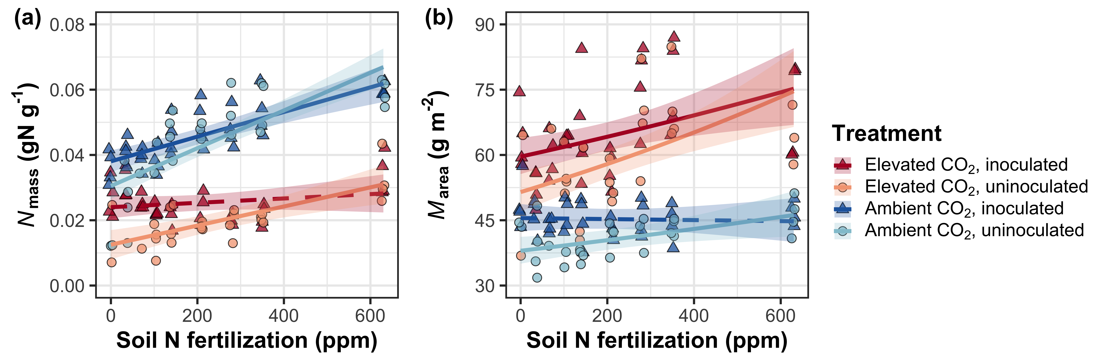

**Figure S1** Effects of CO2, nitrogen fertilization, and inoculation onmass-based leaf nitrogen content (a) and leaf biomass per unit leaf area (b). Nitrogen fertilization is on the x-axis in both panels. Red shaded points and trendlines indicate plants grown under elevated CO2, while blue shaded points and trendlines indicate plants grown under ambient CO2. Light blue and light red circular points and trendlines indicate measurements collected from uninoculated plants, while dark blue and dark red triangular points indicate measurements collected from inoculated plants. Solid trendlines indicate regression slopes that are different from zero (*p*<0.05), while dashed trendlines indicate slopes that are not distinguishable from zero (*p*>0.05).

**Figure S2**

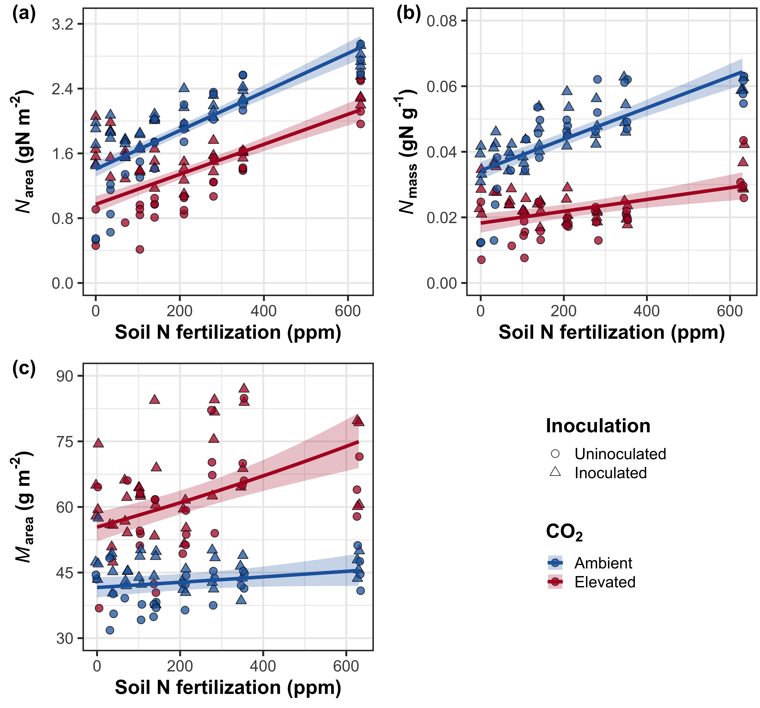

**Figure S2** Effects of CO2 and fertilization inoculation on area-based leaf nitrogen content (a), mass-based leaf nitrogen content (b), and leaf biomass per unit leaf area (c). Nitrogen fertilization is on the x-axis. Red shaded points and trendlines indicate plants grown under elevated CO2, while blue shaded points and trendlines indicate plants grown under ambient CO2. Circular points indicate measurements collected from uninoculated plants, while triangular points indicate measurements collected from inoculated plants. Solid trendlines indicate regression slopes that are different from zero (*p*<0.05).

**Figure S3**

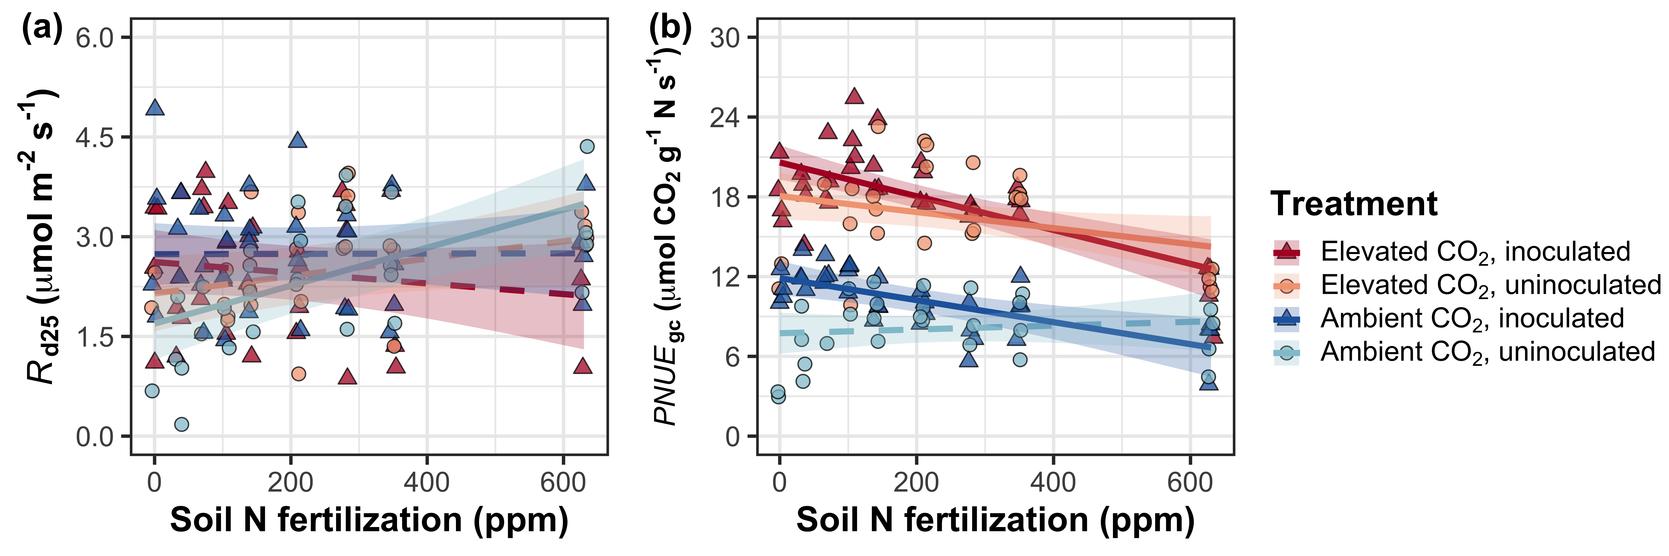

**Figure S3** Effects of nitrogen fertilization, inoculation treatment, and CO2 treatment on dark respiration at 25°C (a) and photosynthetic nitrogen-use efficiency at growth CO2 concentration (b). Nitrogen fertilization is on the x-axis in both panels. Red shaded points and trendlines indicate plants grown under elevated CO2, while blue shaded points and trendlines indicate plants grown under ambient CO2. Light blue and light red circular points and trendlines indicate measurements collected from uninoculated plants, while dark blue and dark red triangular points indicate measurements collected from inoculated plants. Solid trendlines indicate regression slopes that are different from zero (*p*<0.05), while dashed trendlines indicate slopes that are not distinguishable from zero (*p*>0.05).

**Figure S4**

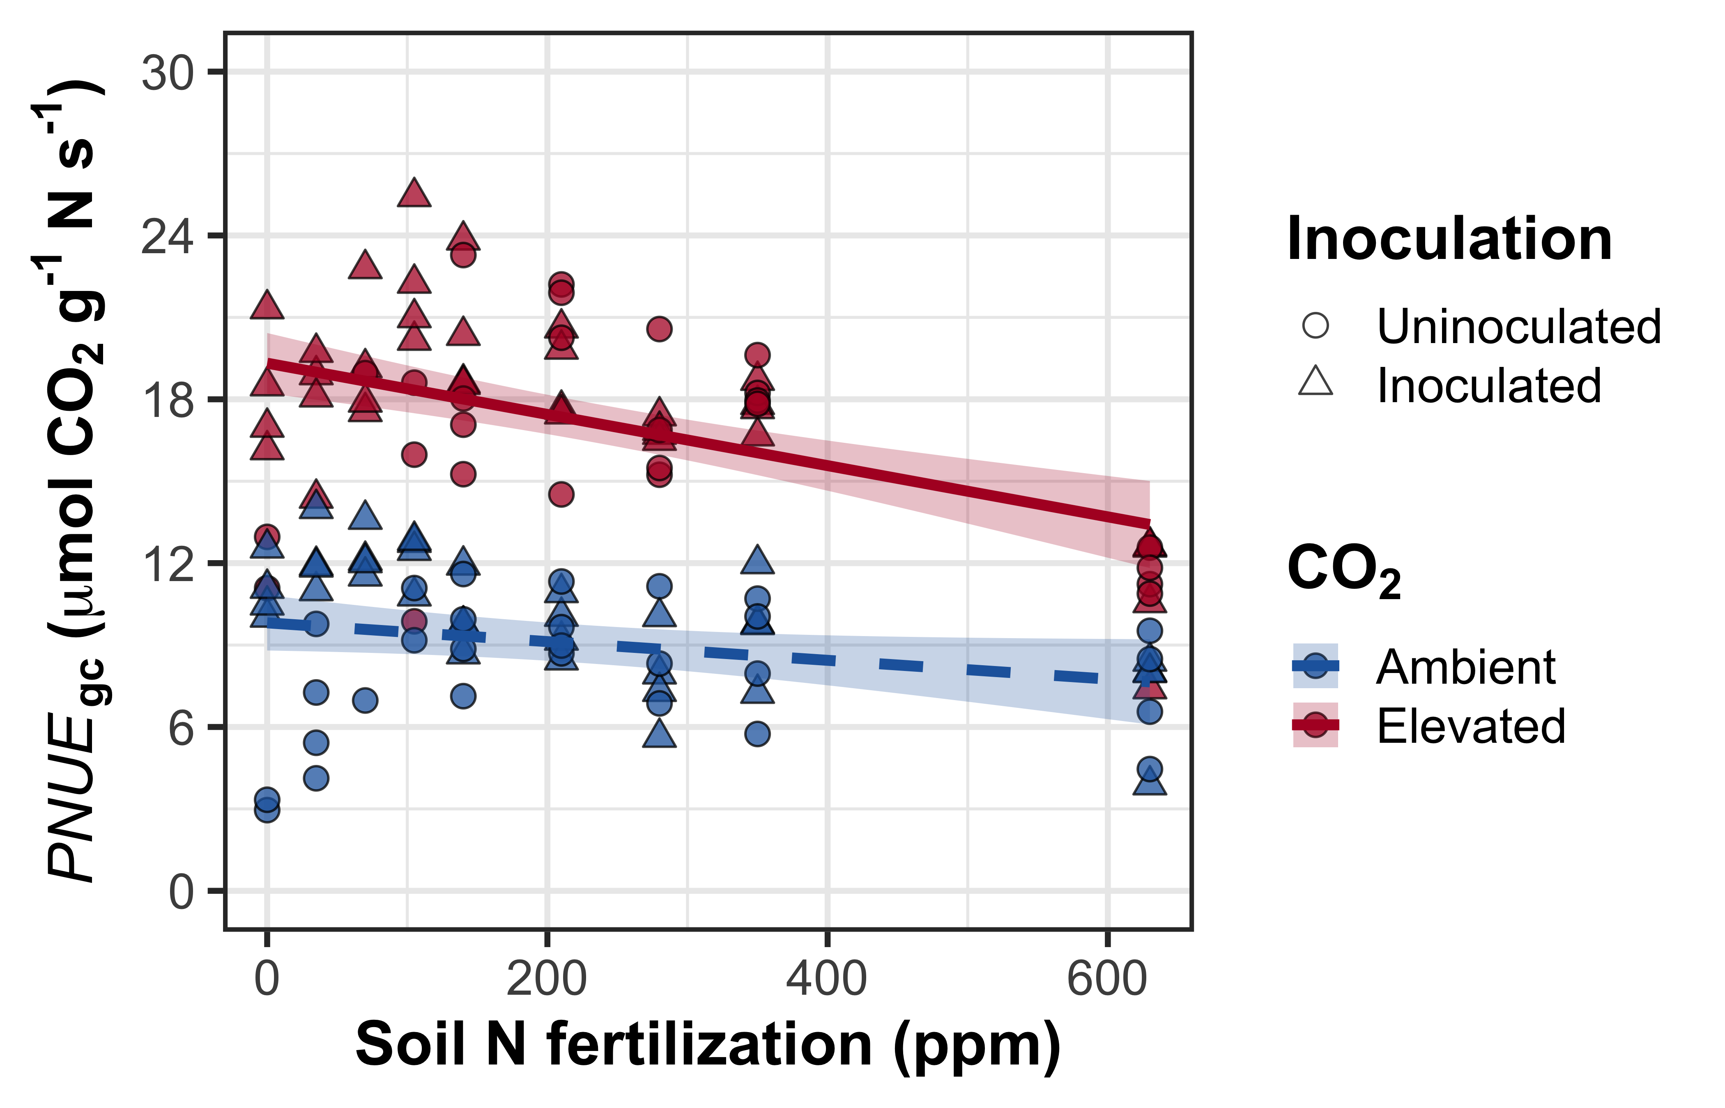

**Figure S4** Effects of CO2 and fertilization inoculation on photosynthetic nitrogen-use efficiency at growth CO2 concentration. Nitrogen fertilization is on the x-axis. Red shaded points and trendlines indicate plants grown under elevated CO2, while blue shaded points and trendlines indicate plants grown under ambient CO2. Circular points indicate measurements collected from uninoculated plants, while triangular points indicate measurements collected from inoculated plants. Solid trendlines indicate regression slopes that are different from zero (*p*<0.05).

**Figure S5**

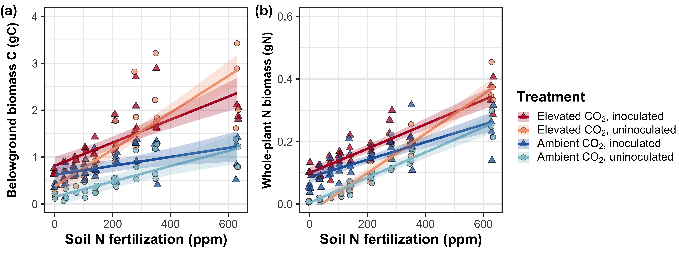

**Figure S5** Effects of CO2 and fertilization inoculation on belowground biomass carbon (a) and total nitrogen biomass (b). Belowground biomass carbon is the numerator of *N*cost, while total nitrogen biomass is the denominator of *N*cost. Nitrogen fertilization is on the x-axis in both panels. Red shaded points and trendlines indicate plants grown under elevated CO2, while blue shaded points and trendlines indicate plants grown under ambient CO2. Light blue and light red circular points and trendlines indicate measurements collected from uninoculated plants, while dark blue and dark red triangular points indicate measurements collected from inoculated plants. Solid trendlines indicate regression slopes that are different from zero (*p*<0.05), while dashed trendlines indicate slopes that are not distinguishable from zero (*p*>0.05).

**Figure S6**

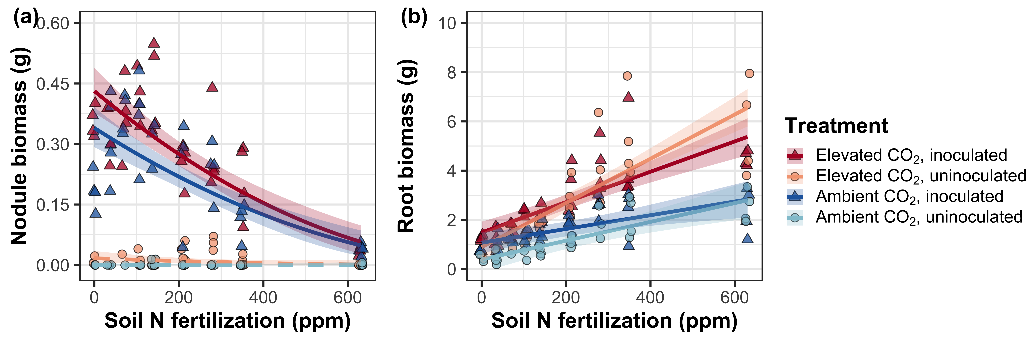

**Figure S6** Effects of nitrogen fertilization, inoculation treatment, and CO2 treatment on root nodule biomass (a), and root biomass (b). Nitrogen fertilization is on the x-axis in both panels. Red shaded points and trendlines indicate plants grown under elevated CO2, while blue shaded points and trendlines indicate plants grown under ambient CO2. Light blue and light red circular points and trendlines indicate measurements collected from uninoculated plants, while dark blue and dark red triangular points indicate measurements collected from inoculated plants. Solid trendlines indicate regression slopes that are different from zero (*p*<0.05), while dashed trendlines indicate slopes that are not distinguishable from zero (*p*>0.05).

**Figure S7**

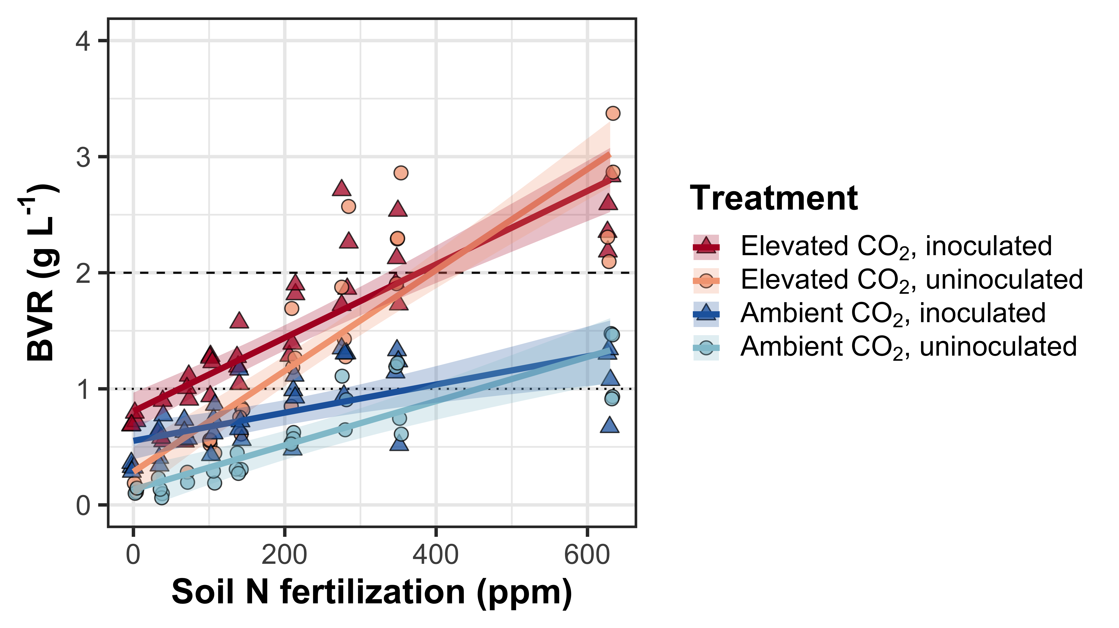

**Figure S7** Effects of CO2, fertilization, and inoculation on the ratio of whole-plant biomass to pot volume. Nitrogen fertilization is on the x-axis in both panels. Red shaded points and trendlines indicate plants grown under elevated CO2, while blue shaded points and trendlines indicate plants grown under ambient CO2. Light blue and light red circular points and trendlines indicate measurements collected from uninoculated plants, while dark blue and dark red triangular points indicate measurements collected from inoculated plants. Solid trendlines indicate regression slopes that are different from zero (*p*<0.05). The dotted horizontal line indicates the point where biomass: pot volume exceeds 1 g L-1, and the dashed line indicates the point where biomass: pot volume exceeds 2 g L-1.